Web Apps Engineering

For this to work , people should post different questions (past papers).

There should be different answers for questions, as everyone is not going off one person's answers.

**2012 WebEng Exam**

<http://exampapers.cit.ie/PastExams/Computing/KWEBD_8_Y3/2013%20Semester1/KWEBD_8_Y3%20SOFT8002%20Engineering%20Web%20Applications.pdf>

**2013 WebEng Exam**

<http://exampapers.cit.ie/PastExams/Computing/KWEBD_8_Y3/2014%20Semester1/KWEBD_8_Y3%20SOFT8002%20Engineering%20Web%20Applications.pdf>

**Link to all of John’s slideshow:** <https://www.dropbox.com/sh/in3sgc9j2xsd01v/AAAfdGXBzapnQg_I1Yymk49Oa?n=117387074>

**Managing Web Projects - Geoff Hewson**

<https://www.dropbox.com/s/4skz5enufum5zg5/MANAGING%20WEB%20PROJECTS.docx?dl=0>

Johns 2014 Paper Layout

WebApp Eng Exam Layout

For each exam questions, the answer may be based on Course material, In-

class research, & In-class discussion/presentation.

Complete **4** questions from the **5** on the exam paper – only first 4 question-

answers on exam script will be corrected as explained in class.

Marks for each question appear on exam paper.

**Q1. 3 parts & subparts. Course materials addressed Cprt 1, Web based systems, & Cptr 2, Web engineering, + In-class research, & In-class discussion/ presentation.**

**Q2. 3 parts & subparts. Course materials addressed Cptr 2, Web engineering, Cptr 3, Web Process, Cptr 4, Communication,+ In-class research, & In-class discussion/presentation.**

**Q3. 2 parts & subparts. Course materials addressed Article: “Managing Web Projects: Recipes for success” by Geoff Hewson. Network model, using activity-on-node notation, + In-class research, & In-class discussion/presentation.**

**Q4. 3 parts & subparts. Course materials addressed Cprt 13, WebApp Design, & Cptr 20, Testing Web Applications, + In-class research, & In-class discussion/presentation. Mostly focused on Design.**

**Q5. 4 parts & subparts. Course materials addressed Cptr 20, Testing Web Applications, Usability Research,+ In-class research, & In-class discussion/presentation.**

Good luck!

*N.B (The layout doesn’t mention chapters 5 & 6 but questions do get asked about it.)*

2013 Exam Questions

**Q1**

**(a)**

**Web engineering, WebE, may be defined as**

**“an agile, yet disciplined framework for building industry,quality WebApps.”**

**Do you agree with the above stated WebE definition? Justify your answer.**

………...

**(b)**

**Elaborate, briefly, on each of the following WebE framework activities:**

1. Communication: Involves heavy interaction and collaboration with the customer and stakeholders. Requirements gathering and other related activities.
2. Planning: Establishes incremental plan for the WebE framework.
3. Modelling:Creation of models to assist developer and customer to better understand requirements and design.
4. Construction: Coding and testing.
5. Deployment: Delivers WebApp increment to the customer who can then provide feedback.

**(c)**

**Any engineering framework needs to be adapted to the problem, the project, the**

**development team, and the organisational culture. Adapting a framework does impact**

**the framework characteristics, including:**

**i.**

**The overall flow of activities, actions, and tasks, and the interdependencies**

**among them.**

**ii.**

**The degree to which work products are identified and required.**

**List five other framework characteristics that are impacted when adapting the WebE framework**

• Overall flow of activities, actions, and tasks and the interdependencies

among them?

• Degree to which work tasks are defined within each framework activity?

• Degree to which work products are identified and required?

• Manner in which quality assurance activities are applied?q-1--a1

• Manner in which project tracking and control activities are applied?

• Overall degree of detail and rigor with which the process is described?

• Degree to which customers and other stakeholders are involved with the

project?

• Level of autonomy given to the software project team?

• Degree to which team organization and roles are prescribed

**(These are all of the characteristics that can be impacted)**

**(d)**

**The Agile Alliance suggested a set of twelve agility principles, including:**

**i. Continuous attention to technical excellence and good design enhances agility.**

**ii. Simplicity – the art of maximising the amount of work not done –is essential.**

**List four other Agile Alliance suggested principles.**

<http://www.agilealliance.org/the-alliance/the-agile-manifesto/the-twelve-principles-of-agile-software/>

* Our highest priority is to satisfy the customer through early and continuous delivery of valuable software.
* Welcome changing requirements, even late in development. Agile processes harness change for the customer's competitive advantage.
* Deliver working software frequently, from a couple of weeks to a couple of months, with a preference to the shorter timescale.
* Business people and developers must work together daily throughout the project.
* Build projects around motivated individuals. Give them the environment and support they need, and trust them to get the job done.
* The most efficient and effective method of conveying information to and within a development team is face-to-face conversation.
* Working software is the primary measure of progress.
* Agile processes promote sustainable development. The sponsors, developers, and users should be able to maintain a constant pace indefinitely.
* Continuous attention to technical excellence and good design enhances agility.
* Simplicity--the art of maximizing the amount of work not done--is essential.
* The best architectures, requirements, and designs emerge from self-organizing teams.
* At regular intervals, the team reflects on how to become more effective, then tunes and adjusts its behavior accordingly.

**(All 12 agility principles)**

**(e)**

**Elaborate, briefly, on each of the following WebE best practices:**

**i. Take the time to understand the business needs and product objectives,**

**even if the details of the WebApp are vague.**

* Communicate with stakeholders in order to understand what you are being asked to do.
* Get the stakeholders involved in the development process so that they have a vested interest in the success of the WebApp

**ii. Don’t reinvent when you can reuse.**

* …...

**iii. Don’t rely on early users to debug the WebApp – design comprehensive**

**tests and execute them before releasing the system.**

* …….

**Q2**

**(a)**

**Negotiation is a critical skill for success in WebApp de**

**velopment. The best**

**negotiators strive for a “win-win” result. Useful guidelines to help with negotiating**

**exist, including:**

**i. Recognise that it is not a competition.**

**ii. Be ready to commit.**

**List five other useful negotiation - guidelines**

•  Recognize that it ’ s not a competition. To be successful, both parties have to

feel they’ve won or achieved something. Both will have to compromise.

•  Map out a strategy. Decide what you’d like to achieve, what the other party

wants to achieve, and how you’ll go about making both happen.

•  Listen actively. Don’t work on formulating your response while the other

party is talking. Listen. It’s likely you’ll gain knowledge that will help you to

better negotiate your position.

•  Focus on the other party ’ s interests. Don’t take hard positions if you want

to avoid conflict.

•  Don’t let it get personal. Focus on the problem that needs to be solved.

•  Be creative. Don’t be afraid to think outside of the box if you’re at an

impasse.

•  Be ready to commit. Once an agreement has been reached, don’t waffle;

commit to it and move on.

**(All seven guidelines)**

**(b)**

**Describe, briefly, how you would manage identified risks on a WebE project.**

* Identify the risk.
* Assess the probability of occurrence.
* Estimate its impact.
* Establish a contingency plan.
* Consider the impact of the risk on the whole project.
* Consider the impact of the risk on the WebApp increment.

**(c)**

**From time-to-time, on a WebE project, the entire team will need to review a work product. List five guidelines that you would use if you were assigned the task of organising and facilitating such a team - review meeting**

Scrum Process????

1. Review the work that has been done.
2. What work is to be done before next meeting.
3. Are there any issues?
4. Decide if changes are to be made.
5. ???

**(d)**

Activity Node Diagram - Have fun with that :P

**Q3**

**(a)**

**Analysis models look at content, interaction, function and behaviour, and the Web**

**configuration. Explain, briefly, how you would determine the amount of analysis**

**required on a WebE project.**

To determine how much analysis modeling to do, examine the:

• Size and complexity of the WebApp increment?

• Number of stakeholders (analysis can help to identify conflicting requirements

coming from different sources)?

• Size of the WebE team?

• Degree to which members of the WebE team have worked together before

(analysis can help develop a common understanding of the project)?

• Degree to which the organization’s success is directly dependent on the

success of the WebApp ?

**(b)**

**Consider the following assertion:**

**“Those who use a WebApp will judge its success. Therefore, it is important that the**

**WebE team understands who the WebApp users will be, what background and skills**

**the users have, how each user category perceives**

**the WebApp, and what features and performance will be required to provide a successful user experience.”**

**Do you agree with the above-assertion? Justify your answer.**

**(c)**

**Explain, briefly, why it is, generally, a good idea to revisit use cases that were used for**

**initial planning and estimation.**

It is a good idea to revisit use cases that were used for initial planning and estimation because:

* Identify overlaps and possible optimizations
* Allow design simplification
* Find gaps and missing details
* Requirements can change over the development lifecycle
* Need to adapt to these changing requirements

**(d)**

**A Webapp-content model is a representation that provides a clear indication of the content that is required to support a usage scenario. The content model includes all analysis classes. Describe, in detail, content model analysis-classes. Use the following**

**headings to structure your presentation:**

1. **Manifestation**
2. **Attributes**
3. **Operations**
4. **Collaborations**

**Q4**

**(a)**

In Class Notes / Discussions

Might not be 100% complete or accurate, just as a warning

WebApp Types

<http://depts.alverno.edu/cil/basic/webapps/typeswebapps.html>

<http://www.sandiego.edu/its/kb/92527>

<http://tomx.inf.elte.hu/twiki/pub/Team/WebEngineeringCourse2/Chapter_01.pdf>

Informational:

· Not interactive

· Read only

· News website

Download:

· Request a file from a server

Customizable:

· User customizes content to specific needs.

Interaction:

· Video call.

· Voice call.

· Instant messaging.

· Email

User Input:

· Requires data from the user.

· Eg, form

Transaction-orientated

· Exchange of money for a service or product.

· Place an order.

· Eg, Amazon

Service-orientated

· Helps a user to complete a task

· Eg, view bank statement.

Portals

· Brings the user to an external site.

Database access

· The user requires access to a large amount of information

Data warehousing

· Extracting information for a large amount of data.

Characteristics of Web Apps

· **Network Intensiveness :** A WebApp resides on a network and must serve the needs of a diverse community of clients

· **Concurrency:** A large number of users may access the WebApp at one time**.**

· **Unpredictable load:** The number of users of the WebApp may vary by from day to day.

· **Performance:** If the user has to wait too long, they may use an alternative service.

· **Availability:** Users expect WebApp to be available on demand, e.g. 24/7/365.

· **Data Driven:** Present text, graphics, audio, video content to the user.

· **Content Sensitive:** Quality and aesthetic of content determines quality of WebApp.

· **Continuous Evolution:** No set planned release schedule. Adapt and evolve over time.

· **Immediacy:** Time to market- days or weeks.

· **Security:** Difficult to limit population of end-users accessing WebApp.

· **Aesthetics:** The look and feel- what the user sees and how they determine the quality.

**Extreme Programming – XP**

· Improve software quality and responsiveness to changing customer requirements.

· It is an agile process.

· Emphasizes teamwork - managers, customers and developers are all equal partners.

· Self-organizing highly productive teams.

· Simplicity, feedback, respect, courage.

· Feedback by testing software.

· Implement changes as suggested.

· Pair programming - one person codes, the other watches - quality control and risk management.

· Collective code ownership - no code ego - the whole team owns the code.

· Sustainable pace. - Set realistic deadlines.

· Test-driven development - test code after each iteration.

**Sources**

<http://en.wikipedia.org/wiki/Extreme_programming>

<http://www.extremeprogramming.org/>

<http://xprogramming.com/what-is-extreme-programming/>

<http://c2.com/cgi/wiki?ExtremeProgrammingExplainedEmbraceChange> (Kent Beck)

**SCRUM Process**

· It emphasises communication and collaboration, functioning software, and being able to adapt to business needs.

· Projects divided into sections called “Sprints” – 1 to 3 weeks in duration.

· At the end of each Sprint, stakeholders meet to assess the progress and plan the next steps.

· There are three roles in SCRUM.

· Product Owner, ScrumMaster and the development team.

**Product Owner**

· Single Person.

· Represents customer’s interests.

· Decides what it to be completed within each Sprint.

**ScrumMaster**

· Helps the project go as smoothly as possible.

· Helps the team to remain creative and productive.

**Development Team**

· Responsible for completing the project.

· Successful when located in the same physical location.

· 7 +- two members

**Empirical Process**

· Use real world progress when planning.

· Making decisions based on what is known.

**Daily Scrum**

· 15 minute meeting.

· Reviewing work done since last meeting.

· Forecasting work to be done before the next.

**Sprint Review**

· Held at end of each Sprint to assess the work that has been done.

· Decide if changes need to be made.

**Sources**

<https://www.scrum.org/Resources/What-is-Scrum>

<http://scrummethodology.com/>

<http://scrumreferencecard.com/scrum-reference-card/>

<http://www.scrumguides.org/scrum-guide.html> (Jeff Sutherland and Ken Schwaber)

**SMART Objectives**

· **S for specific**: during each sprint planning, the team agrees on a specific set of tasks to achieve, and commits to doing them. The tasks (and the user stories), answer the questions of what do I want to accomplish, purposes/benefits of accomplishing the goal, who is involved, where it takes place, and constraints.

· **M for measurable**: the list of these tasks, plus the movement of the tickets throughout the sprint, from development to code review to QA to release (or whatever your flow is), answers the questions of how much work and when will it be accomplished.

· **A for attainable**: functioning Agile groups don't typically commit to something in the planning stage unless it is clearly attainable -- all the pieces are there to know how to accomplish it

· **R for relevant**: questions like is it worthwhile, is it the right time, does it match our other efforts -- stories and tasks don't get pulled into a sprint, and committed to, unless the answer is yes to all these questions (typically...YMMV)

· **T for time-bound**: a sprint is necessarily time-bound, be it 2 weeks, 3 weeks, more, or less.

[**http://programmers.stackexchange.com/questions/184137/how-to-write-smart-objectives-as-an-agile-developer**](http://programmers.stackexchange.com/questions/184137/how-to-write-smart-objectives-as-an-agile-developer)

The WebE Process

· Agile

· Adaptable

· Incremental

**Why Incremental?**

· Requirements evolve.

· Changes happen frequently.

· Time lines are short.

· Incremental **-** allowsyou to manage this change.

**Conducting Framework Activities**

First Iteration - Communication

· Define business context.

· Gather requirements.

· Usage scenarios.

· Needs of shareholders.

· Derive set of increments.

· Develop broad outline of components.

Second Iteration - Planning

· Develop plan.

· Create model of WebApp.

· Get stakeholder feedback on model.

· Begin construction of increment - use model as a guide.

· Get feedback from stakeholders.

· Identify scope of development effort

**Umbrella Activities**

Occur in parallel with main development. Equally important to the success of a project.

· Change Management: Manages effect of change as each increment is engineered.

· Quality Assurance: Tasks that help insure that increment exhibits quality.

· Risk Management: considers projects and technical risks as an increment is engineered.

· Project Management: Monitors progress as an increment is engineered.

**Risk Management**

· Risk - future event that may or may not occur. If it does, it will have an adverse effect on the project.

· Ranked based on probability of occurrence and likely impact (monetary value).

· Contingency fund/plan - Allocate time at the end of the project to recap and fix things if necessary.

**Other Notes**

· Lean management - do only the essentials.

· The new product development game - origins of SCRUM and other agile processes.

· Capability Maturity Model - Watts Humphrey.

· PSP, TSP, USP - Personal, Team, Universal Software Process.

· Pair Programming - One person codes, the other watches - Quality assurance and risk management.

· Clean room software engineering.

**Agile Manifesto:** <http://agilemanifesto.org/>

**Individuals and interactions** over processes and tools,

**Working software** over comprehensive documentation,

**Customer collaboration** over contract negotiation,

**Responding to change** over following a plan.

**What is a WebE Framework?**

· A framework is a set of activities that will always be performed for every WebE project.

· Composed of a set of actions.

o Work tasks.

o Work products.

o Quality assurance points.

o Project milestones.

**Roger Pressman – WebE Framework**

· **Communication:** Interaction and Collaboration

· **Planning:** Incremental plan

· **Modelling:** Creation of models to aid understanding

· **Construction:** Actual coding and testing to uncover errors in code.

· **Deployment:** Delivers WebApp increment to customer who evaluates it and provides feedback based on evaluation.

**Statement of Scope**

· Written before project start.

· Gives the outline of the project.

· Should be concise and clear

· Should be specific

**Good Example:** The catalogue will feature 100 products.

**Bad Example:** The catalogue will have a lot of products

# Use Case : Thanks to mark for this

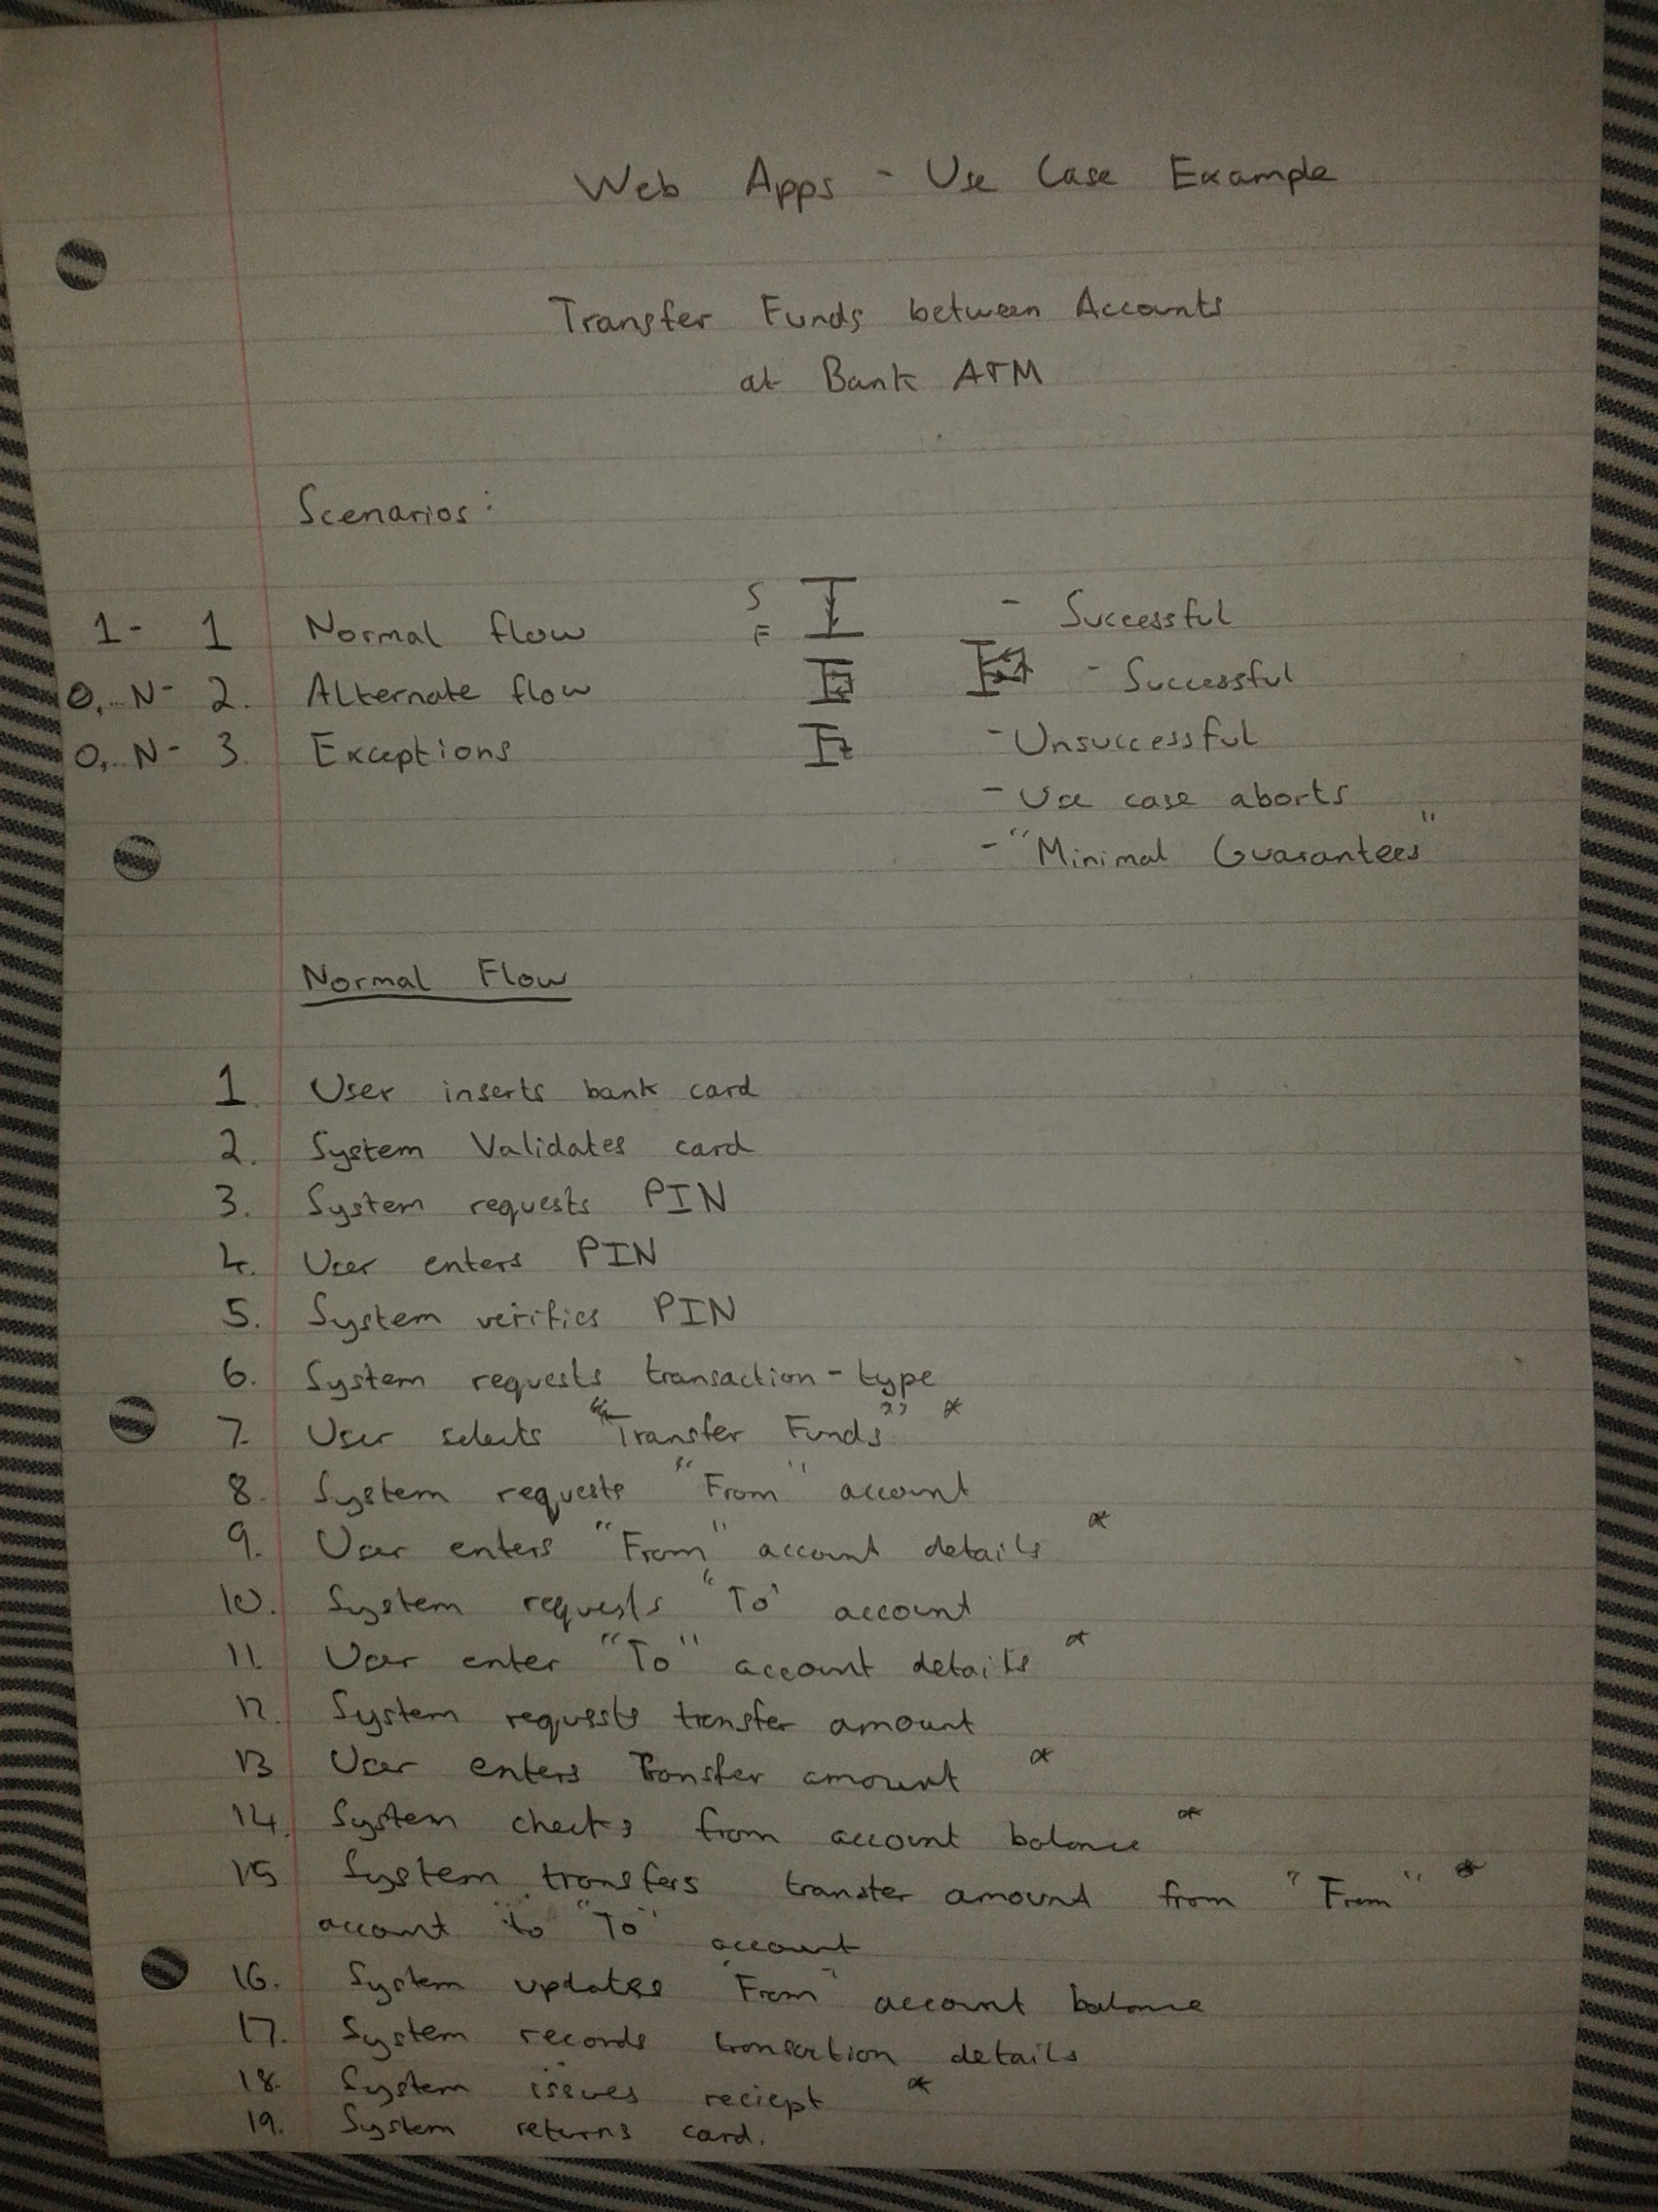

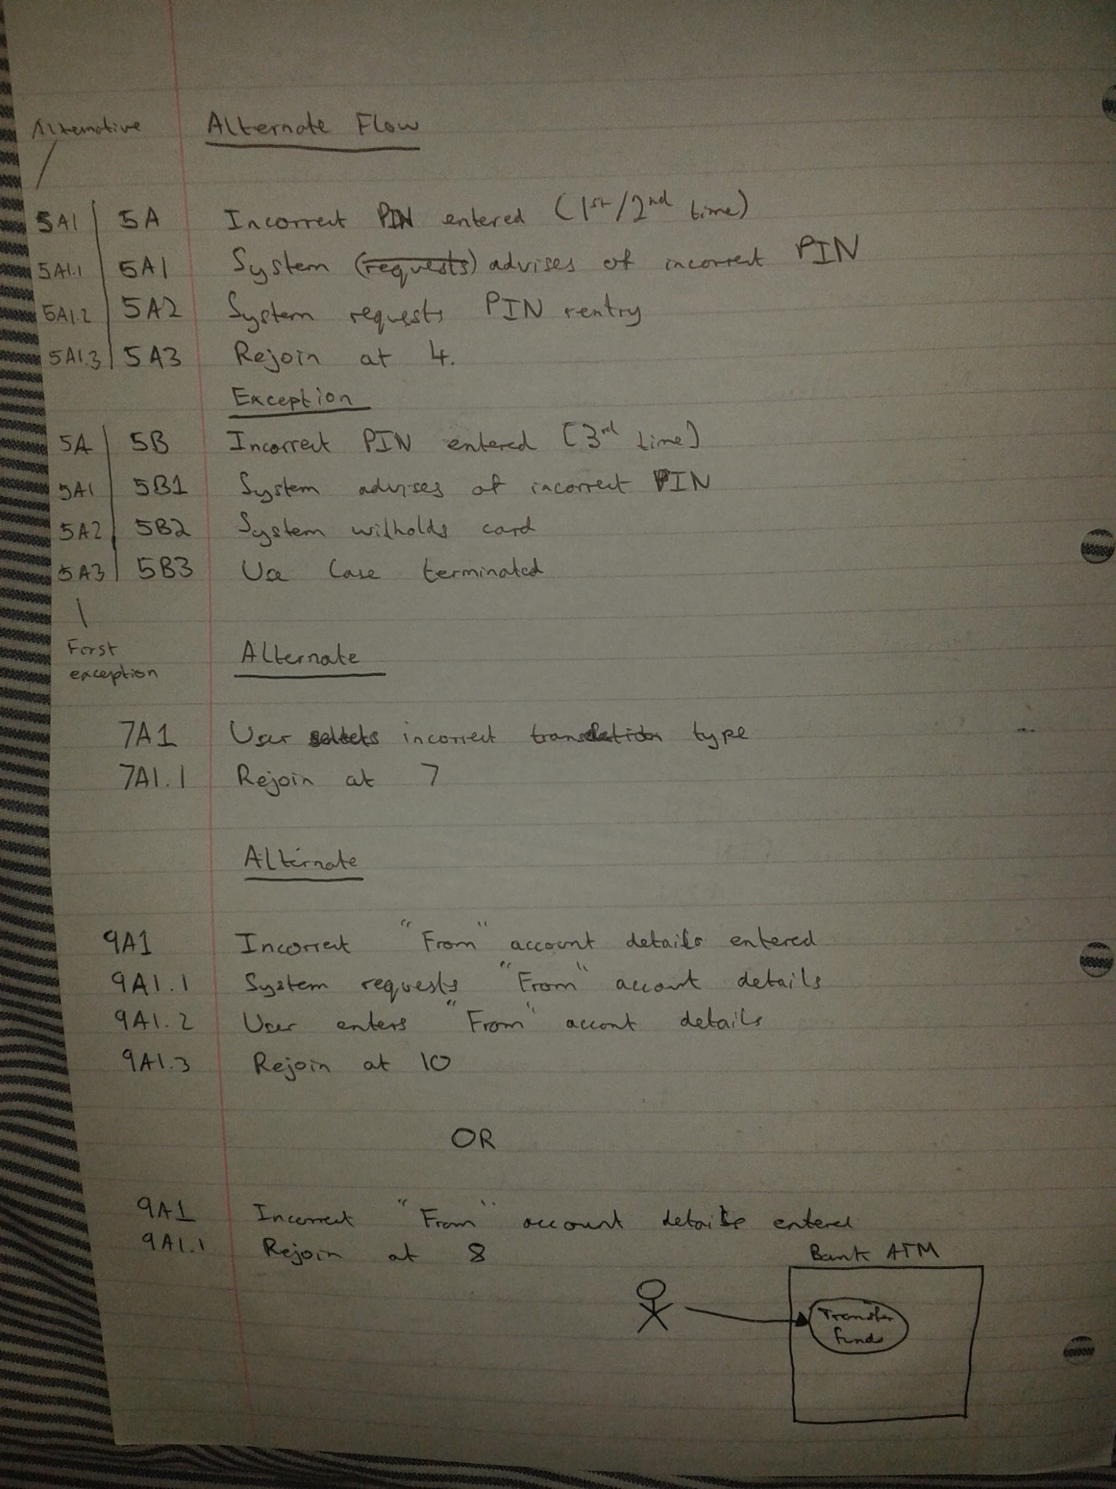î

**Network Diagram**

<http://www.freepmstudy.com/pdffiles/networkdiagram.pdf>

10850614_985899134770823_1063194008_n.jpg

10685322_985899668104103_1733740917_n.jpg

Note; in this case the critical path is B -> E -> H

This is because there is no float time between activities. (i.e. once one is finished you go straight into the next one)

Another indication that this is the critical path is that both forward and backward passes have the same timeline (0-7…...7-1…...11-16)